**Problem Identification overview:** Big Mountain Resort has recently installed an additional chair lift to help increase the

distribution of visitors across the mountain. This additional chair increases their

operating costs by $1,540,000 t. This business profit margin is 9.2% and the investors would like to keep it there.

**Identify data needed:** data contains information from 330 resorts in the US, the number of runs, the number of trams, the number of chairlifts, Average annual snowfall, Cost of adult Weekday and weekend Chairlifts.

**Best Model Result**: a linear regression model used for adult weekend chairlift price and the Model has two measures: The explained Variance score and the Mean Absolute Error. The Explained Variance Score is .513.

**Data Preprocessing:**

. Create Dummy variables for state, remove the original column for state.

. Restore were grouped by summit elevation and vertical drop.

. 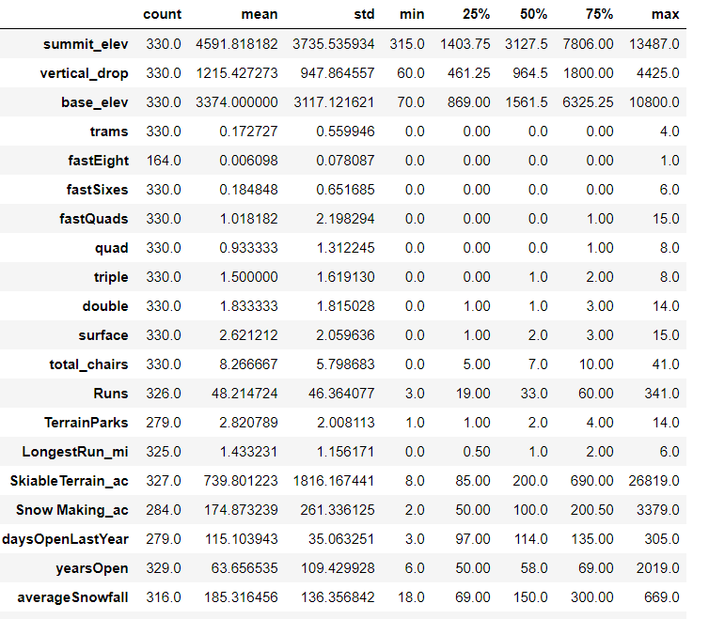

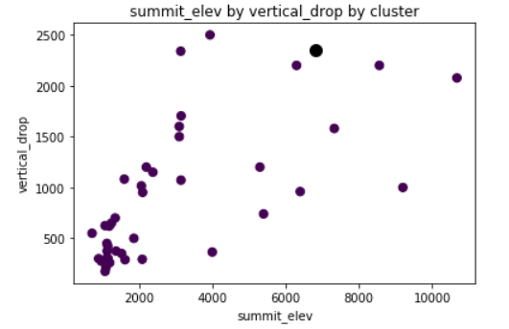

**Model Development:**

**The results from each of the three Models:**

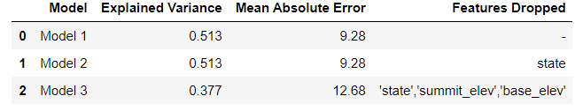

**Model Findings:**

. Predicted value of Adult Weekend Chairlift Price for Big Mountain: $89

. Adult Weekday Chairlift price was most significant.

**Recommendation:**

1.Since Adult weekend and Adult weekday are high demand, both prices should be changed to $89.

2.Based on estimate of 350,000 visitors per year, this should result increased revenue of $1,750,000.

Increased revenue needs to be 1.092*1,540,000=1,681,680(profit margin of %9.2).